How DSL Works
When you connect to the Internet, you might connect through a regular modem, through a local-area network connection in your office, through a cable modem or through a digital subscriber line (DSL) connection. DSL is a very high-speed connection that uses the same wires as a regular telephone line.
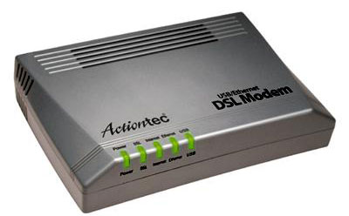
Photo courtesy HowStuffWorks Shopper
A DSL modem

Here are some advantages of DSL:
- You can leave your Internet connection open and still use the phone line for voice calls.
- The speed is much higher than a regular modem
- DSL doesn't necessarily require new wiring; it can use the phone line you already have.
- The company that offers DSL will usually provide the modem as part of the installation.
But there are disadvantages:
- A DSL connection works better when you are closer to the provider's central office. The farther away you get from the central office, the weaker the signal becomes.
- The connection is faster for receiving data than it is for sending data over the Internet.
- The service is not available everywhere.
In this article, we explain how a DSL connection manages to squeeze more information through a standard phone line -- and lets you make regular telephone calls even when you're online.
Telephone Lines
If you have read How Telephones Work, then you know that a standard telephone installation in the United States consists of a pair of copper wires that the phone company installs in your home. The copper wires have lots of room for carrying more than your phone conversations -- they are capable of handling a much greater bandwidth, or range of frequencies, than that demanded for voice. DSL exploits this "extra capacity" to carry information on the wire without disturbing the line's ability to carry conversations. The entire plan is based on matching particular frequencies to specific tasks.
To understand DSL, you first need to know a couple of things about a normal telephone line -- the kind that telephone professionals call POTS, for Plain Old Telephone Service. One of the ways that POTS makes the most of the telephone company's wires and equipment is by limiting the frequencies that the switches, telephones and other equipment will carry. Human voices, speaking in normal conversational tones, can be carried in a frequency range of 0 to 3,400 Hertz (cycles per second -- see How Telephones Work for a great demonstration of this). This range of frequencies is tiny. For example, compare this to the range of most stereo speakers, which cover from roughly 20 Hertz to 20,000 Hertz. And the wires themselves have the potential to handle frequencies up to several million Hertz in most cases.
The use of such a small portion of the wire's total bandwidth is historical -- remember that the telephone system has been in place, using a pair of copper wires to each home, for about a century. By limiting the frequencies carried over the lines, the telephone system can pack lots of wires into a very small space without worrying about interference between lines. Modern equipment that sends digital rather than analog data can safely use much more of the telephone line's capacity. DSL does just that.
A DSL internet connection is one of many effective communication tools for keeping employees in touch with the office.
More on Home Networking
VDSL | Home Networking | Cable Modems | Modems | Telephones | Fiber Optics | WiFi | LAN Switches | Ethernet | Routers | Internet Infrastructure | Firewalls | Power-line Networking | Phone-line Networking | WAP | PDAs | Laptops | PCs
Asymmetric DSL
Most homes and small business users are connected to an asymmetric DSL (ADSL) line. ADSL divides up the available frequencies in a line on the assumption that most Internet users look at, or download, much more information than they send, or upload. Under this assumption, if the connection speed from the Internet to the user is three to four times faster than the connection from the user back to the Internet, then the user will see the most benefit most of the time.
Precisely how much benefit you see from ADSL will greatly depend on how far you are from the central office of the company providing the ADSL service. ADSL is a distance-sensitive technology: As the connection's length increases, the signal quality decreases and the connection speed goes down. The limit for ADSL service is 18,000 feet (5,460 meters), though for speed and quality of service reasons many ADSL providers place a lower limit on the distances for the service. At the extremes of the distance limits, ADSL customers may see speeds far below the promised maximums, while customers nearer the central office have faster connections and may see extremely high speeds in the future. ADSL technology can provide maximum downstream (Internet to customer) speeds of up to 8 megabits per second (Mbps) at a distance of about 6,000 feet (1,820 meters), and upstream speeds of up to 640 kilobits per second (Kbps). In practice, the best speeds widely offered today are 1.5 Mbps downstream, with upstream speeds varying between 64 and 640 Kbps. Some vast improvements to ADSL are available in some areas through services called ASDL2 and ASDL2+. ASDL2 increases downstream to 12 Mbps and upstream to 1 Mbps, and ASDL2+ is even better -- it improves downstream to as much as 24 Mbps and upstream to 3 Mbps.

Photo courtesy Corning
DSL signals can't pass through
fiber-optic cables.
You might wonder -- if distance is a limitation for DSL, why is it not also a limitation for voice telephone calls? The answer lies in small amplifiers called loading coils that the telephone company uses to boost voice signals. Unfortunately, these loading coils are incompatible with ADSL signals, so a voice coil in the loop between your telephone and the telephone company's central office will disqualify you from receiving ADSL. Other factors that might disqualify you from receiving ADSL include:
- Bridge taps - These are extensions, between you and the central office, that extend service to other customers. While you wouldn't notice these bridge taps in normal phone service, they may take the total length of the circuit beyond the distance limits of the service provider.
- Fiber-optic cables - ADSL signals can't pass through the conversion from analog to digital and back to analog that occurs if a portion of your telephone circuit comes through fiber-optic cables.
- Distance - Even if you know where your central office is (don't be surprised if you don't -- the telephone companies don't advertise their locations), looking at a map is no indication of the distance a signal must travel between your house and the office.
Next, we'll look at how the signal is split and what equipment DSL uses.
Splitting the Signal
The CAP System
There are two competing and incompatible standards for ADSL. The official ANSI standard for ADSL is a system called discrete multitone, or DMT. According to equipment manufacturers, most of the ADSL equipment installed today uses DMT. An earlier and more easily implemented standard was the carrierless amplitude/phase (CAP) system, which was used on many of the early installations of ADSL.
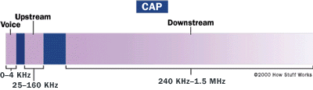
CAP operates by dividing the signals on the telephone line into three distinct bands: Voice conversations are carried in the 0 to 4 KHz (kilohertz) band, as they are in all POTS circuits. The upstream channel (from the user back to the server) is carried in a band between 25 and 160 KHz. The downstream channel (from the server to the user) begins at 240 KHz and goes up to a point that varies depending on a number of conditions (line length, line noise, number of users in a particular telephone company switch) but has a maximum of about 1.5 MHz (megahertz). This system, with the three channels widely separated, minimizes the possibility of interference between the channels on one line, or between the signals on different lines.
The DMT System
DMT also divides signals into separate channels, but doesn't use two fairly broad channels for upstream and downstream data. Instead, DMT divides the data into 247 separate channels, each 4 KHz wide.
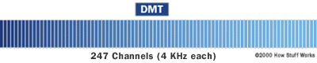
One way to think about it is to imagine that the phone company divides your copper line into 247 different 4-KHz lines and then attaches a modem to each one. You get the equivalent of 247 modems connected to your computer at once. Each channel is monitored and, if the quality is too impaired, the signal is shifted to another channel. This system constantly shifts signals between different channels, searching for the best channels for transmission and reception. In addition, some of the lower channels (those starting at about 8 KHz), are used as bidirectional channels, for upstream and downstream information. Monitoring and sorting out the information on the bidirectional channels, and keeping up with the quality of all 247 channels, makes DMT more complex to implement than CAP, but gives it more flexibility on lines of differing quality.
Filters
CAP and DMT are similar in one way that you can see as a DSL user.
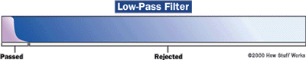
If you have ADSL installed, you were almost certainly given small filters to attach to the outlets that don't provide the signal to your ADSL modem. These filters are low-pass filters -- simple filters that block all signals above a certain frequency. Since all voice conversations take place below 4 KHz, the low-pass (LP) filters are built to block everything above 4 KHz, preventing the data signals from interfering with standard telephone calls.
DSL Equipment
ADSL uses two pieces of equipment, one on the customer end and one at the Internet service provider, telephone company or other provider of DSL services. At the customer's location there is a DSL transceiver, which may also provide other services. The DSL service provider has a DSL Access Multiplexer (DSLAM) to receive customer connections.
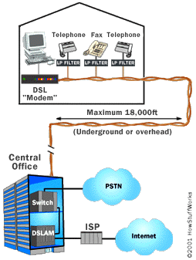
The Transceiver
Most residential customers call their DSL transceiver a "DSL modem." The engineers at the telephone company or ISP call it an ATU-R. Regardless of what it's called, it's the point where data from the user's computer or network is connected to the DSL line.
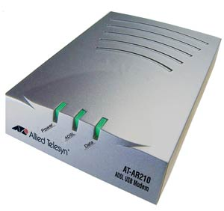
Photo courtesy Allied Telesyn
DSL modem
The transceiver can connect to a customer's equipment in several ways, though most residential installation uses USB or 10 base-T Ethernet connections. While most of the ADSL transceivers sold by ISPs and telephone companies are simply transceivers, the devices used by businesses may combine network routers, network switches or other networking equipment in the same platform.
The DSLAM
The DSLAM at the access provider is the equipment that really allows DSL to happen. A DSLAM takes connections from many customers and aggregates them onto a single, high-capacity connection to the Internet. DSLAMs are generally flexible and able to support multiple types of DSL in a single central office, and different varieties of protocol and modulation -- both CAP and DMT, for example -- in the same type of DSL. In addition, the DSLAM may provide additional functions including routing or dynamic IP address assignment for the customers.
The DSLAM provides one of the main differences between user service through ADSL and through cable modems. Because cable-modem users generally share a network loop that runs through a neighborhood, adding users means lowering performance in many instances. ADSL provides a dedicated connection from each user back to the DSLAM, meaning that users won't see a performance decrease as new users are added -- until the total number of users begins to saturate the single, high-speed connection to the Internet. At that point, an upgrade by the service provider can provide additional performance for all the users connected to the DSLAM.
For information on ADSL rates and availability in the United States, go to Broadband Reports. This site can provide information on ADSL service companies in your area, the rates they charge, and customer satisfaction, as well as estimating how far you are from the nearest central office.
ADSL isn't the only type of DSL, and it's not the only way to get high-speed Internet access. Next, we'll look at ADSL alternatives.
Alternatives to ADSL
There are lots of variations in DSL technology -- many of them address DSL's distance limitations in one way or another. Other types of DSL include:
- Very high bit-rate DSL (VDSL) - This is a fast connection, but works only over a short distance. It is capable of handling Internet access, HDTV and on-demand services at rates of 52 Mbps downstream and 12 Mbps upstream.
- Symmetric DSL (SDSL) - This connection, used mainly by small businesses, doesn't allow you to use the phone at the same time, but the speed of receiving and sending data is the same.
- Rate-adaptive DSL (RADSL) - This is a variation of ADSL, but the modem can adjust the speed of the connection depending on the length and quality of the line.
- ISDN DSL (IDSL) - This is a combination of the Integrated Services Digital Network (ISDN) and DSL technology. ISDN was the solution to dial-up Internet -- it allowed voice, text graphics, video and other data to share one telephone line. This made it possible to talk on the phone and use the Internet at the same time. IDSL is faster than ISDN connections but slower than DSL. It can travel a longer distance of 5 to 6 miles, so it is usually a good option for people who can't get DSL in their area.
- Universal DLS (Uni-DSL) - This emerging technology, developed by Texas Instruments, is backwards compatible with all existing versions of DSL. It offers somewhat of a middle ground between ASDL and VDSL -- at longer distances, it can reach the speeds of ASDL, but it can provide greater speeds than VDSL at shorter distances. In some locations, Uni-DSL can provide four times the amount of speed as VDSL.
Alternatives to DSL
With DSL's distance limitation and lower availability, what are some other options? There are two major alternatives to DSL -- cable and wireless.

Cable and DSL are the two big rivals in the world of broadband. Cable isn't limited by distance like DSL -- cable wires reach most neighborhoods, and signal strengths don't weaken over long distances. While DSL allows you to use the telephone and Internet simultaneously, cable lets users watch television and surf the Internet at the same time. Many cable companies are also beginning to bundle services with cable TV, Internet and digital telephone on one bill. Although cable and DSL speeds are about the same, the one disadvantage with cable is bandwidth -- connection speeds can slow down if too many people are using a cable service at the same time.
A new technology, known as WiMax or 802.16, looks to combine the benefits of broadband and wireless. WiMax will provide high-speed wireless Internet over very long distances and will most likely provide access to large areas such as cities. WiMax technology will be available in most American cities in 2008.

